Verkada Proof of Concept Criteria

COMPANY LOGO

“MISSION STATEMENT”

Table of Contents

1. POC Goals and Overview 3
A. Document Purpose 3
B. Business Challenge 3
C. Objective 3
2. POC Site Design 4
3. Scope 5
4. Success Criteria 5
5. Stakeholders 7
6. POC Schedule 8
7. Next Steps 8

1. POC Goals and Overview

Document Purpose
The document will serve as the agreement between Verkada and “CUSTOMER” as to the scope and measures of success for a proof of concept engagement to demonstrate and document the proposed physical security solution to “CUSTOMER”.

Business Challenge
CUSTOMER is challenged with managing several antiquated on premise physical security solutions, many of which may have failing hardware. Managing these systems continues to be timely and costly. In addition, the current solutions lack modern AI capabilities, advanced analytics, continuous software development/updates, and integration into third-party software solutions and a Point-Of-Sale (POS) system.

Objective
Verkada is pleased to be working with CUSTOMER in conducting a Proof-of-Concept (POC) to demonstrate the capabilities of the Verkada Physical Security platform.
The objectives of this POC are to:
- Demonstrate the feasibility of implementing a physical security solution that is modern, secure, easy to use, scalable, and supports integration with third-party applications.
- Identify any potential risks or challenges that could impact a successful POC.
- Gather feedback from key stakeholders, to align with CUSTOMER’s business challenge.

2. POC Site Design
- MOCK STORE

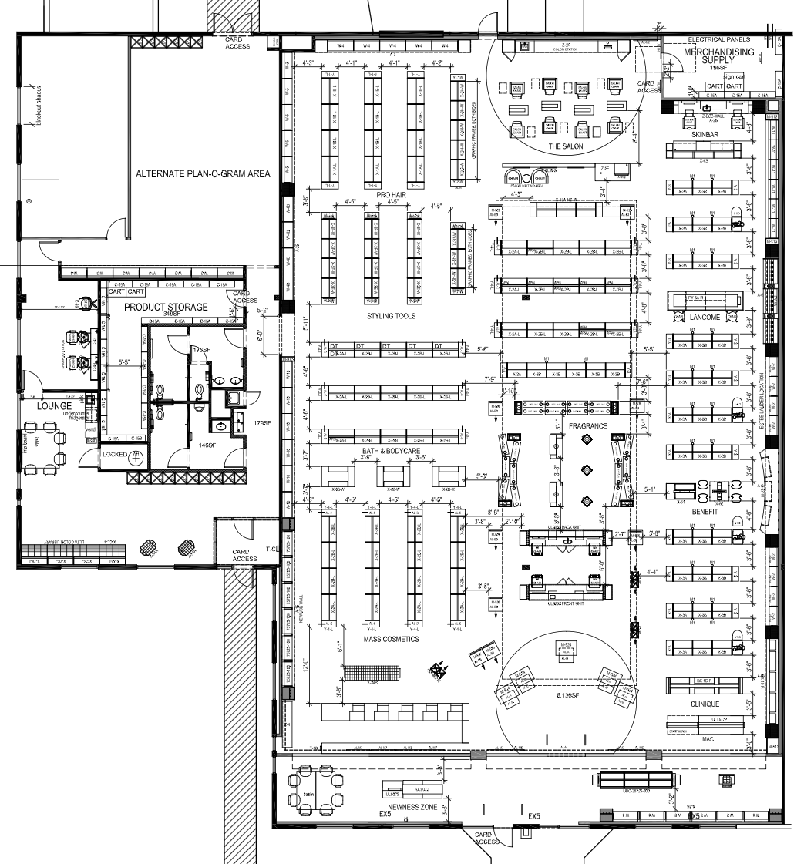

3. Scope
The scope of this POC includes the following:

- Verkada will provide the following:
  - Video Security (Cameras)
  - Hybrid cloud cameras offer onboard storage and edge–based processing to reliably deliver AI-powered insights in real–time.
- Video Security (Command Connector)
  - Support for non-Verkada camera hardware, to provide a path forward toward a single management platform.
- CUSTOMER will provide the following:
  - Dedicated internet access for Verkada devices to communicate with Verkada Command
  - Network connectivity with Power-Over-Ethernet (PoE) capability to Verkada devices
  - Technical resources to support the installation and configuration of in scope physical security solutions

4. Success Criteria
The success criteria for this POC are as follows:

- Unified, Seamless, and Scalable System
  - The POC must demonstrate the ability to integrate cameras, access control, alarms, and other systems into a single, easy-to-use platform that can be scaled across CUSTOMER’s locations.
  - The system should support thousands of devices and users, enabling seamless control and monitoring.
- Qualify AI Capabilities & Advanced Features
  - The POC should successfully demonstrate the AI and advanced analytics capabilities of the platform, as well as the seamless integration across products.
    - AI Powered Search - Use freeform text to search for people and vehicles in a highly-detailed manner.
    - AI Powered Alerts - AIerts using freeform text search.
    - Loitering - People or vehicles detected stationary for a period of time.
    - Crowd - A group of people or vehicles detected.
    - Occupancy Trends - Estimate of foot traffic at critical locations.
    - People Heatmaps - Detailed view of activity within a building by visualizing individuals' movement history. This helps businesses analyze space utilization, identify high-traffic areas, and understand movement patterns and behavior.
    - Person of Interest - Know when a specific face is detected on a camera in your organization, and identify when your cameras detect a specific face that you choose or upload.
- Multi-System Integration and Simplification
  - The POC should validate Verkada’s capability to integrate multiple security systems (cameras, access control, and alarms) into one platform, reducing the complexity of managing disparate systems.
  - It must also prove that the platform is easy for the security team to use and maintain across different locations.
- Proactive Maintenance and System Updates
  - The POC should show how Verkada’s platform can proactively alert the team to system issues (e.g., cameras going offline) and perform automatic updates, reducing maintenance costs and avoiding system downtime.
- Reduction in Maintenance and Break/Fix Costs
  - The system should provide evidence that it can reduce ongoing maintenance and break/fix costs compared to current systems through automated monitoring and streamlined management.
  - All SKUs as part of this POC come with a 10 year warranty to ensure overall reduction of traditional device replacement cost.
- Scalability Without Added Complexity
  - The POC must demonstrate that Verkada’s platform can scale with CUSTOMER’s growth without introducing additional complexity, keeping the system easy to manage even as locations and users increase.
- Integration Capabilities
  - The POC should prove that Verkada’s platform integrates seamlessly with CUSTOMER’s existing systems, and can incorporate future technologies without requiring major reconfigurations.
    - Auror - Export video archives from Verkada Command to Auror to consolidate and disseminate footage to a network of retailers and law enforcement in order to better identify repeat offenders.
    - Agilence - Pair Verkada cameras with Agilence’s advanced analytics platform to quickly identify and review suspicious transactions or operational anomalies.
    - Microsoft Entra ID - Integrate with Microsoft Entra ID, in the following capacities:
- Security Assertion Markup Language (SAML)
- System for Cross-Domain Identity Management (SCIM)

5. Stakeholders
The stakeholders for this proof of concept are as follows:

6. POC Schedule

Activity | Start Date | End Date | Required Personnel
Discovery
Mock Store Installation
Mock Store Configuration
Mock Store Best Practice/Training
Site Walk(s)
POC Installation
POC Configuration
Reassess Success Criteria
Meet with Leadership / Review POC
Obtain Executive Approval
Purchase

7. Next Steps
The next steps for this proof of concept are as follows:

- Analyze the feedback from users.
- Present the POC to the stakeholders for approval.
- Discuss timeline for purchase of Project.

